**CEO and Irfan Marazi of Flock Industry from Mumbai met Cultural Counsellor of Iran on 27th Sept, 2021 at Iran Culture House New Delhi**

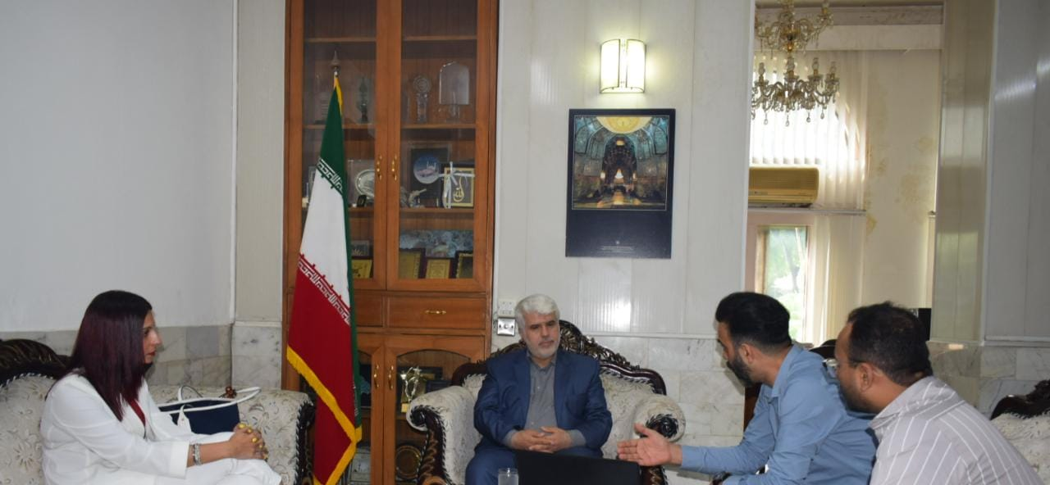

Mrs. Preeti Kumeri the CEO, Mr. Irfan Marazi COO and Mr. Dinesh Jain Head contents of Flock Industry, Mumbai met Dr. Mohd Ali Rabbani Cultural Counsellor and Head Iran Culture House today and exchanged views on the ways and means for the promotion of Iranian Films and Culture. They have already shown more than 25 Iranian movies and are keen on collaboration with Iranian Film Industries, Directors and Producers.

They are keen to organize Iranian Film Festival and have appreciated the view of Cultural Counsellor on the formation of Indo-Iran film Society or Association. Ideas were also exchanged to create opportunity for Indian film directors and producers for shooting in Iran.

They will try their best to promote Iranian movies especially documentary on Art, Culture, Tourism and others.

Dr. Rabbani emphasized on the importance of role of Cinema and Art in strengthening of Indo-Iran Cultural Relation.